DEBOJYOTI CHAKRABORTY
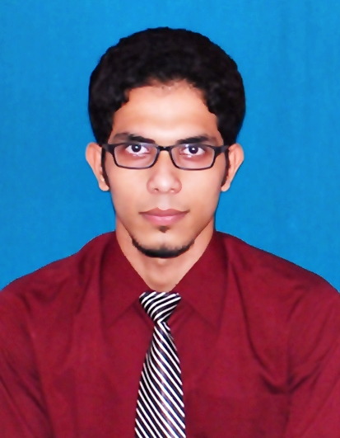
Address:Suddhowala Chowk, Dehradun, Uttarakhand
Email: debojyoti.chakraborty19@gmail.com
Skype ID: iamdebojyoti
LinkedIn URL: in.linkedin.com/in/iamdebojyoti
Contact No: +919836741667, +917060728685

Career Objective:
Obtain a position as a team-player in a people-oriented organization where I can utilize my strong organizational skills & educational background in a challenging environment to achieve the corporate goals.
Global Certifications:
- Certified Ethical Hacker(CEH): Version 9
- Oracle Certified Java Programmer(OCJP) : Java Standard Edition 6.0
- Microsoft Certified Technology Specialist (MCTS): SQL Server 2008, Database Development
Professional Qualification:
- Completed GNIIT (Software Engineering) from NIIT in 2014
- Completed Ethical Hacking from Indian School of Ethical Hacking in 2014
- Completed Certificate in Software Engineering from Ramakrishna Mission Shilpamandira Computer Centre accredited by DOECC in 2011
Experience Summary:
- Currently working as a faculty in CRAFT (Cyber Radix Academy for Future Technology).
- Having 8 months of experience as a part time web developer in Monaestry.
Technical Skills:
- Programming Languages- C, C++, Core JAVA, Python
- Web Technologies- JSP, Servlet
- Web Scripts: HTML, XML, CSS, JavaScript
- Database- Oracle 10g, MySQL
- Operating Systems- MS-DOS, Windows (XP,7,8,8.1,10), Unix, Kali Linux
- Others- Networking, Ethical Hacking.
Academic Qualifications:
- MSc(IT) from HNB Garhwal Central University with 77% in 2016
- BSc(IT) from Kuvempu University in 2014 with 65%
- XII (WBCHSE Board) from PCS GOVT. HIGH SCHOOL in 2009 with 66%
- X (WBBSE Board) from SATYABHARATI VIDYAPITH in 2007 with 67%
Project Handeled:

- Remote KeyLogger
- Duration: 2 months
- Team Members: 1
- Roll Played: Developer
- Platforms: Python

- TCP/UDP Port Scanner
- Duration: 2 months
- Team Members: 1
- Roll Played: Developer
- Platforms: Python

- Online Banking Web Application
- Duration: 1 month
- Team Members: 3
- Roll Played: Designer, Developer and Tester
- Platforms: JSP, Core JAVA, Microsoft Access 2003

- Tech Support Web Application
- Duration: 2 month
- Team Members: 3
- Roll Played: Designer, Developer and Tester
- Platforms: JSP, SERVLET, Core Java, Oracle 10g

- E-Learning Web application
- Duration: 1 month
- Team Members: 3
- Roll Played: Designer, Developer and Tester
- Platforms: ASP.NET, C#.NET, Microsoft SQL Server 2008

Achievements:
- 1st prize winner in College Software Competition (Innovation 2014)
- 2nd prize winner in College Quize Competition
- Man of the Match award winner in Inter College Cricket Championship

Personal Information:
- Date of Birth : 30/03/1991
- Permanent Address : KabiSukantaSarani, Nabapally, Barasat, Kolkata-700126,WestBengal,India

Languages Known:

- Bengali, Hindi, English

Strengths:

Sincere & hardworking, patience, ability to work in a team, ability to adjust in all situation, eagerness to learn, always have positive attitude towards life.

Declaration:

I, hereby, declare that all the statements made here and the information furnished the best of my knowledge and belief.

Place: 
Date: (Candidate’s Signature)

